Date | 1 NOVEMBER 2025
Team ID | NM2025TMID05413
Project Name | Educational Organisation Using  ServiceNow
Maximum Marks | 5 Marks
Project Design Phase – II
Technology Stack (Architecture & Stack)

Technical Architecture:
This project manages educational processes using ServiceNow by automating admissions, student progress, and Salesforce data. It enables admins to efficiently create, update, and track records through forms and auto-number generation, ensuring scalability and real-time access in the ServiceNow cloud.
Example: Student admission and progress tracking in educational institutions using ServiceNow.

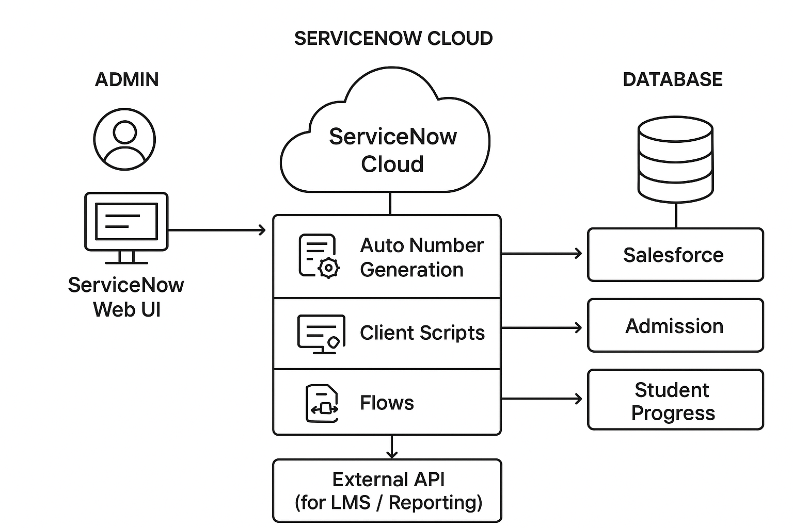

Guidelines:
The architecture includes all major processes such as admission management, student progress tracking, and Salesforce integration, represented as application logic blocks. It operates on the ServiceNow cloud (SaaS) platform with automated workflows like auto-number generation and client scripts. Data is securely stored in Admission, Salesforce, and Student Progress tables, with optional API integration for external LMS systems.

Table-1: Components & Technologies:
S.No | Component | Description | Technology
1 | User Interface | Admin and staff interact through ServiceNow web dashboard. | ServiceNow Web UI
2 | Application Logic-1 | Manages auto-generation of Admission Numbers. | Business Rules, Server Script
3 | Application Logic-2 | Validates student details and avoids duplicate entries. | Client Script, GlideRecord
4 | Application Logic-3 | Updates and tracks student progress records. | Flow Designer
5 | Database | Stores Admission, Salesforce, and Student Progress details. | ServiceNow Tables
6 | Cloud Database | Data maintained on ServiceNow cloud platform. | ServiceNow Cloud Database
7 | File Storage | Minimal use, logs and reports stored internally. | ServiceNow File Storage
8 | External API-1 | Optional LMS integration for reports. | REST API in ServiceNow
9 | External API-2 | Not applicable. | –
10 | Machine Learning Model | Not applicable for this phase. | –
11 | Infrastructure (Cloud) | Hosted on ServiceNow SaaS environment. | ServiceNow Cloud (SaaS)

Table-2: Application Characteristics:

S.No | Characteristics | Description | Technology
1 | Open-Source Frameworks | Not applicable (ServiceNow is proprietary). | –
2 | Security Implementations | Role-based access control and ACL for secure user data handling. | ServiceNow ACL, Roles, Scoped Apps
3 | Scalable Architecture | SaaS-based system, scalable through ServiceNow’s cloud architecture. | ServiceNow Cloud Platform
4 | Availability | High uptime ensured by ServiceNow-managed hosting and redundancy. | Load-balanced Instances
5 | Performance | Optimized through GlideRecord queries and efficient background scripts. | GlideRecord, Business Rules

